**TASK 1**

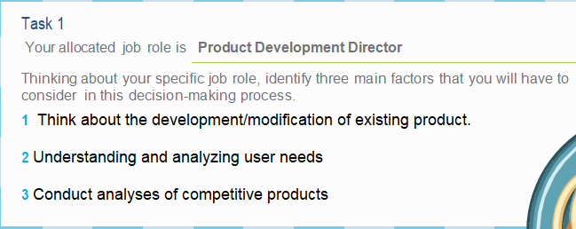

**TASK 2**

|  |  |
| --- | --- |
| **FILE** |  |
| **1** | **58.83% customer increase in ten year in chilled ready meals and main meal.** |
| **2** | **Main target audience is younger consumer and farm-food products are fast growing grocer in 2014 and Iceland too teamed up with slimming world in 2015**  **to sell a new range of frozen ready meals.** |
| **3** | **Healthy food products are main customer/consumer focus and government also create impact towards healthier eating.** |
| **4** | **The trend changing from eating out to dining in with the specific preference for higher and convenience lines(premium ready meals) as a result premium ready meals becomes cash conscious while frozen and chilled market was in decline.** |
| **5** | **Main focus on market research and product development.** |
| **6** | **Company is maintaining its quality to stick their position in the market and the customer need is changing as premium product provides convenient meal solution which give it major rise in market value;however, frozen sector rises around 4.5% and chilled sector rises around 6.5%** |
| **7** | **Waitrose penetrates current market through a new line called waitrose 1 which consists of 520 items. This market is already acquired by Aldi and Lidl.Waitrose also wants to achieve £500m target.** |
| **8** | **In Russia due to economic crises, People's disposable income decreases so people try to cook food in their home.**  **In the USA, due to wealth increases and change in tests of them they mainly prefer restaurants or call and get dining out products**  **In France, people try to use their cooking time by doing other activities so they make the habit of fast available meals which increase the market of chilled ready products etc.** |

**TASK 3**

|  |  |  |
| --- | --- | --- |
| **Ready meal** | **PROS** | **CONS** |
| Children |  |  |
| Diet |  |  |
| Premium |  |  |
| Family |  |  |